Student mini-project
Project title: Prompt Engineering for an AI-Based College Helpdesk

Project requirements
Students design prompts for a chatbot that answers questions about:
- Department timetables
- Laboratory requirements
- Examination procedures
- Course information
- Approved college notices

Suggested architecture

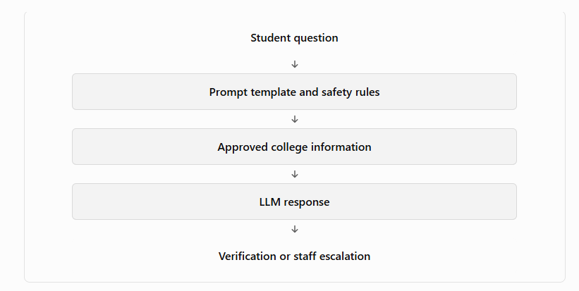Deliverables
- Prompt templates
- Ten or more test questions
- Screenshots of model responses
- Accuracy and completeness assessment
- Error analysis
- Privacy and safety considerations
- Final project report
Students should use fictional or publicly approved information rather than personal student records.

